Day83 - Task41 - Kubernetes(Part-05)

1. Create a namespace dev-environment and apply a resource-based quota that restricts the number of pods to 3 and services to 2.

Step 1. Create the namespace
- kubectl create namespace dev-environment
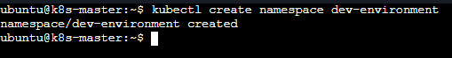

Step 2. Create the ResourceQuota YAML
- vi resource-quota.yaml and add
- Save and exit.
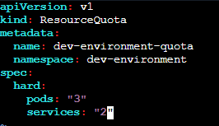
Step 3. Apply the quota
- kubectl apply -f resource-quota.yaml
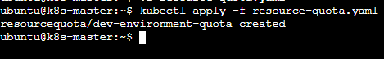

Step 4. Verify the namespace
- kubectl get namespace dev-environment
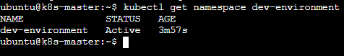

Step 5. Verify the ResourceQuota
- kubectl get resourcequota -n dev-environment
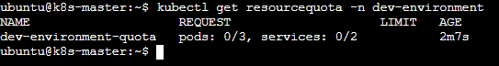
2. Create a pod in the prod-environment namespace with 0.2 CPU and 200Mi memory requests, and 0.5 CPU and 500Mi memory limits.

Step 1. Create the prod-environment namespace
- kubectl create namespace prod-environment
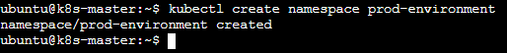
Step 2. Create the Pod YAML
- vi prod-pod.yaml and add
- Save and exit.
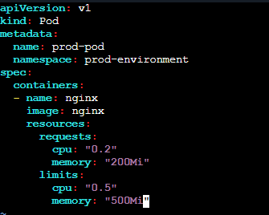

Step 3. Apply it
- kubectl apply -f prod-pod.yaml
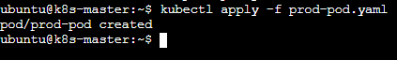

Step 4. Verify
- kubectl get pod -n prod-environment
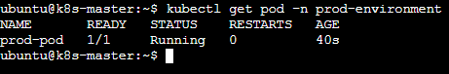

Step 5.Check the resource settings:
- kubectl describe pod prod-pod -n prod-environment
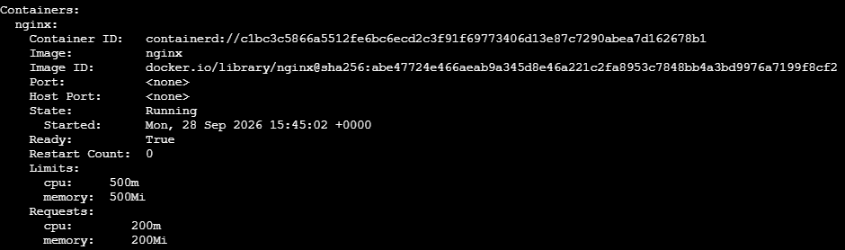
3. In the staging-environment namespace, set a LimitRange that assigns default CPU and memory limits (300m CPU, 600Mi memory) and applies a minimum and maximum CPU.

Step 1. Create the namespace
- kubectl create namespace staging-environment
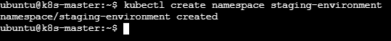

Step 2. Create the LimitRange
- vi staging-limitrange.yaml and add
- Save and exit.
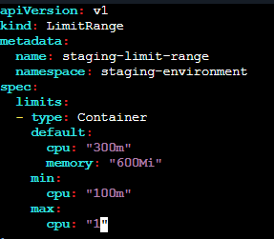

Step 3. Apply it
- kubectl apply -f staging-limitrange.yaml
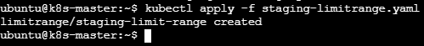

Step 4. Verify
- kubectl get limitrange -n staging-environment
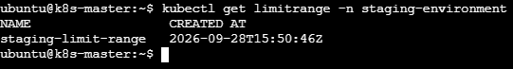
- For details: kubectl describe limitrange staging-limit-range -n staging-environment
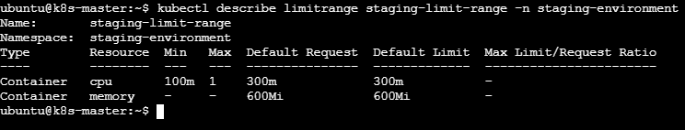
4. Create a pod and a NodePort service in the default namespace, then create another pod in the test namespace and communicate between them using Service DNS.

Step 1. Create the Pod in default
- kubectl run nginx-pod --image=nginx
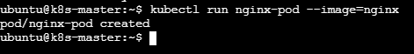
- Verify: kubectl get pod nginx-pod
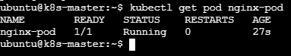

Step 2. Create the NodePort Service
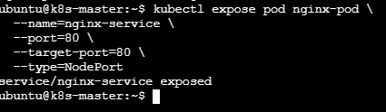
- Verify: kubectl get svc nginx-service
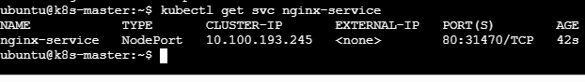
Step 3. Create the test namespace
- kubectl create namespace test
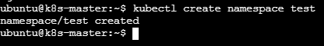

Step 4. Create another Pod in test
- Use curlimages/curl because it already contains curl:
- Now we are inside the test pod: ~ $

Step 5. Communicate using Service DNS
- Because the Service is in the default namespace, use: curl http://nginx-service.default.svc.cluster.local
- We have to receive the Nginx HTML response: Later exit out of container
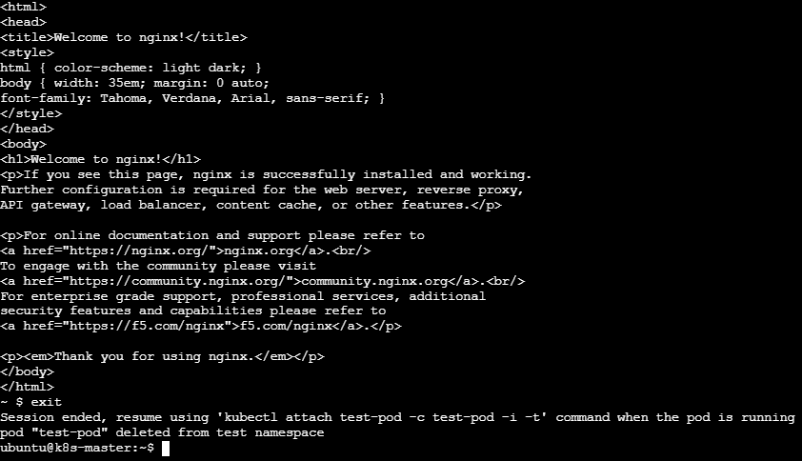

5. Apply a LimitRange with a max limit/request ratio of 2 for memory in the performance-environment namespace, and test by creating a pod with mismatched resource requests and limits.

Step 1. Create the namespace
- kubectl create namespace performance-environment
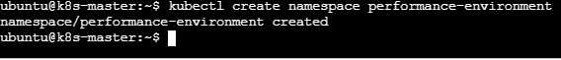

Step 2. Create the LimitRange
- vi performance-limitrange.yaml and add
- Save and exit.
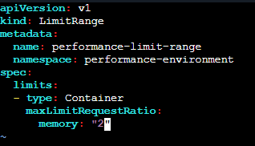

Step 3. Apply it:
- kubectl apply -f performance-limitrange.yaml
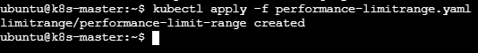

Step 4. Verify the LimitRange
- kubectl describe limitrange performance-limit-range -n performance-environment
You should see:
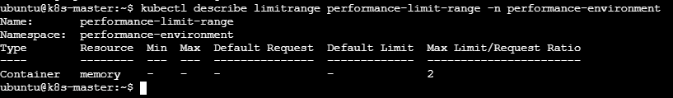
Step 5. Create a Pod with mismatched memory
- Now create a Pod where:
  - Memory request = 100Mi
  - Memory limit = 500Mi
- The ratio is: 500Mi / 100Mi = 5
- But the allowed maximum ratio is 2, so Kubernetes should reject it.

Step 6 .Create vi test-ratio-pod.yaml
- Add: 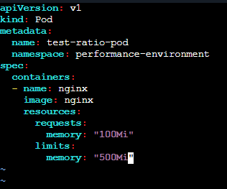
- Save and exit.
Step 7. Apply:
- kubectl apply -f test-ratio-pod.yaml
- Expected result: The Pod should NOT be created. You should get an error similar to:
- Error from server (Forbidden):
pods "test-ratio-pod" is forbidden:
memory max limit to request ratio per Container is 2,
but provided ratio is 5

